Project Design Phase-II
Technology Stack (Architecture & Stack)

Date | 31 January 3035
Team ID | 10 april 2026
Project Name | Earth-meet(video calling app)
Maximum Marks | 4 Marks

Technical Architecture: 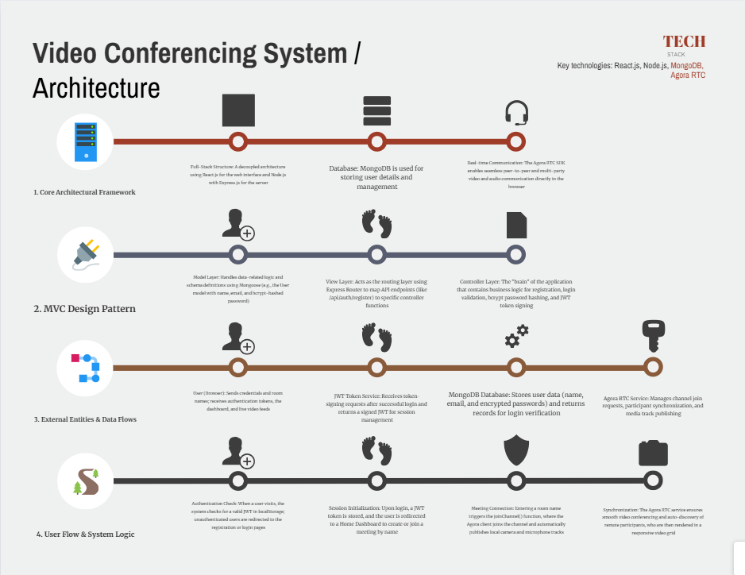

Table-1 : Components & Technologies:
Component | Description | Technologies Used
User Interface | Handles user interaction with the platform, rendered directly in the browser. | React.js 18, Tailwind CSS, Vite
Client-Side Application Logic | Manages the frontend logic, including routing, authentication guards, token storage, and Agora channel interactions. | JavaScript (ES6+), React Router v6
Server-Side Application Logic | Manages backend processes such as user registration, login validation, and security hashing. | Node.js, Express.js, bcrypt library
Database Management | NoSQL storage for user documents; employs schema validation and is designed for future cloud migration. | MongoDB, Mongoose ODM
Real-Time Communication (RTC) | External API enabling low-latency, multi-party video and audio streaming via WebRTC. | Agora RTC SDK, WebRTC
Secure Authentication | Provides stateless session management via signed tokens for protected requests. | jsonwebtoken, localStorage

Table-2: Application Characteristics:
Feature Name | Functional Category | Description | Technology Stack
User Registration | Authentication & Security | Allows new users to sign up with name, email, and password; passwords are stored as bcrypt hashes for data protection. | Node.js, Express.js, MongoDB, bcrypt
User Login | Authentication & Security | Authenticates user credentials and returns a signed JWT token for secure, stateless session management. | Node.js, Express.js, JWT (jsonwebtoken), bcrypt
Create a Meeting Room | Meeting Management | Authenticated users can instantly create a new meeting room by entering a custom name. | React.js, Node.js, Agora RTC SDK
Join a Meeting Room | Meeting Management | Users can join an active live session by entering a shared room code or room name. | React.js, Node.js, Agora RTC SDK
Live Video & Audio | Real-time Communication | Provides multi-party video and audio communication directly in the browser with low-latency synchrony. | Agora RTC SDK
Protected Routes | Authentication & Security | Prevents unauthorized access to sensitive pages like the Home Dashboard and Meeting Rooms without a valid token. | React Router v6, JWT, localStorage
Mute / Unmute Microphone | Real-time Communication | Provides interactive media controls to toggle local audio tracks on or off during an active session. | Agora RTC SDK
Stop / Start Camera | Real-time Communication | Provides interactive media controls to toggle local video tracks on or off without leaving the room. | Agora RTC SDK
Remote User Grid | Real-time Communication | Features presence tracking that automatically discovers and renders remote participants in a responsive layout. | React.js, Tailwind CSS, Agora RTC SDK
Responsive UI | Frontend / UI/UX | Utilizes Tailwind CSS to create a "glassmorphism" interface that adapts to various screen sizes and devices. | Tailwind CSS, React.js
Clean Leave | Meeting Management | Ensures media tracks are properly released and the user is disconnected from the channel upon exiting to preserve system performance. | Agora RTC SDK, JavaScript

